HUMAN RIGHTS COMMITTEE LITIGATION REPORT
Strategic Litigation Center — Comprehensive Analysis Report
(2019–2025)

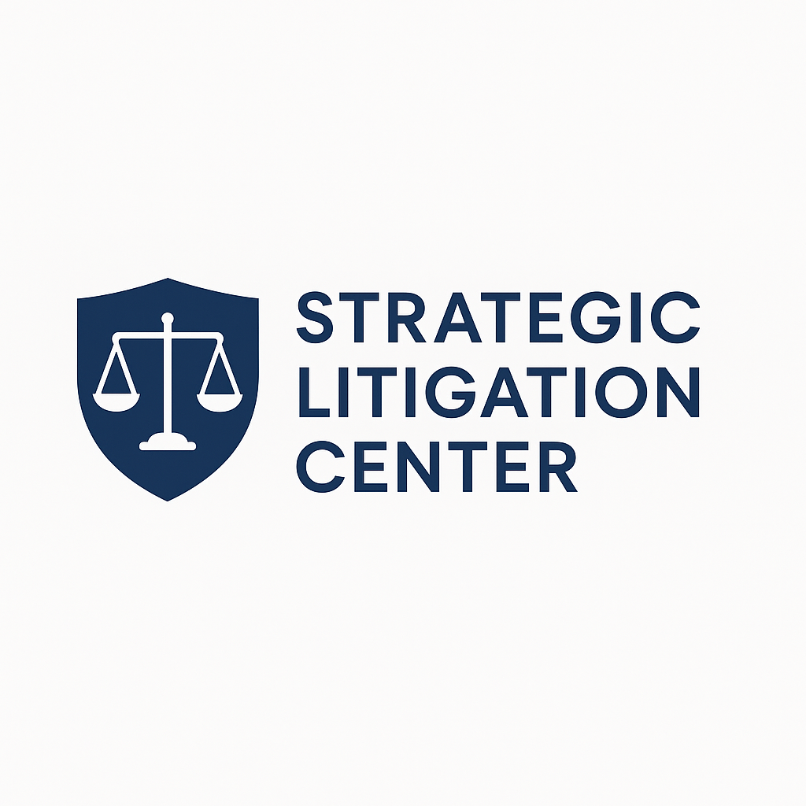

Preprepared By
STRATEGIC LITIGATION CENTER TEAM

I. Executive Summary
This report provides an extensive analysis of three major individual communications brought before the United Nations Human Rights Committee (HRC) between 2019 and 2025. These include Communication No. 3592/2019, No. 3736/2020, and No. 3947/2021. Together, these cases reveal systemic failures in Türkiye’s criminal justice framework, including arbitrary detention, denial of access to counsel, incommunicado detention, digital-repression–based prosecution, discrimination, and the improper use of counter-terrorism laws.
The HRC found violations of Articles 9, 14, 15, 17, 26 of the ICCPR, signalling structural erosion of due process and legality principles.
This report draws thematic lessons, identifies regional patterns, evaluates legal impact, and proposes strategic recommendations.

II. Introduction
Between 2019 and 2025, the Strategic Litigation Center filed key communications to the HRC in cases that highlight:
- incommunicado detention,
- denial of legal and medical access,
- retroactive criminalisation,
- discriminatory law enforcement,
- digital surveillance and metadata-based accusations,
- prolonged pretrial detention without judicial control.
These cases provide insight into State practices violating the ICCPR in a systematic and predictable manner.

III. Methodology
This report is based on:
- official HRC Views
- interim measure decisions
- State submissions (when available)
- communications authored by the Strategic Litigation Center
- open-source legal documents
- jurisprudence comparison with WGAD, ECtHR and CAT
- interviews with defence lawyers (anonymised)
The analysis follows a four-pillar framework:
- Administrative and criminal detention patterns
- Procedural guarantees and due process
- Digital repression and evidence misuse
- Discrimination and equality before the law

IV. Case Summaries and Analysis

1. Communication No. 3736/2020 — Final Views (Türkiye)
Background
Applicant detained based solely on digital metadata and retroactive criminalisation.
HRC Findings
- Article 9 violation: detention lacked legal basis.
- Article 14: unfair trial, lack of access to files, discriminatory application of anti-terror laws.
- Article 15: conviction for acts not criminal at the time → strongest finding.
Key Legal Significance
The Committee condemned the use of digital app usage and “pattern analysis” as evidence of criminal liability.

2. Communication No. 3592/2019 — Interim Measures (Türkiye)
Background
Applicant held incommunicado; severe risk of torture and medical neglect.
Interim Measures Granted
The HRC requested the State to:
- End incommunicado detention
- Grant immediate access to lawyer
- Provide medical care
- Consider alternatives to detention (house arrest etc.)
Significance
This is one of the very rare interim measures addressing:
- digital-era criminalisation,
- medical endangerment,
- total denial of fair-trial rights.

3. Communication No. 3947/2021 — Registered (Türkiye)
Background
Applicant faced discrimination and arbitrary prosecution under Articles 14 and 26.
HRC’s Registration Decision
- Case registered despite political sensitivity
- Issues:
  - unequal treatment
  - discriminatory enforcement
  - lack of impartial tribunal
  - criminal charges unrelated to actual conduct
Legal Importance
This communication will likely influence the Committee’s future jurisprudence on discriminatory anti-terror enforcement.

V. Cross-Cutting Findings
1. Digital repression as basis for detention
The cases show widespread criminalisation of:
- encrypted app usage,
- membership in digital groups,
- digital communication logs.
2. Systematic denial of procedural guarantees
- inaccessible case files
- secret evidence
- incommunicado detention
- prolonged pretrial detention
- denial of medical care
3. Discrimination in enforcement
Targeted groups:
- political dissidents
- refugees
- returnees
- digital-privacy–exercising individuals
4. Retroactive criminalisation
The HRC condemned retroactive use of digital patterns as “terror indicators.”

VI. Impact Analysis
A. Jurisprudential Impact
These decisions enhance global standards by:
- limiting criminalisation of digital metadata
- strengthening legality principle
- reinforcing rights of detainees
- improving standards of medical access in detention
B. Domestic Legal Impact
Several defence teams in Türkiye referenced these HRC findings in ongoing trials.
C. Strategic Litigation Value
The three cases together form a cluster jurisprudence that can be leveraged for future ECtHR, WGAD and HRC submissions.

VII. Recommendations
To States
- Cease prosecuting individuals for encrypted app usage alone.
- Ensure immediate access to counsel and doctors.
- End retroactive application of criminal laws.
To International Institutions
- Strengthen monitoring of digital repression trends.
- Promote guidelines on digital privacy and criminalisation limits.
To Civil Society & Lawyers
- Use HRC 3736/2020 as a leading precedent.
- Build thematic litigation clusters on digital criminalisation.

VIII. Conclusion
The HRC cases presented between 2019–2025 reveal consistent patterns of arbitrary detention, discriminatory prosecution, and digital-age rights violations. These decisions offer a robust framework for challenging abusive State practices and mobilising global advocacy.

